**Internet of Things with Cloud**

The cloud computing and Internet Of Things are very closely related future internet technologies in which one providing the other platform for innovation and development. Internet Cloud Services is a set of technologies which can be viewed as network-connected devices used in the physical environment for improvements in infrastructure. It also used to add new scenario to previous ones for the advancement.

The Internet of Things (IoT) is a system of interrelated computing devices, mechanical and digital machines, objects, animals or people that are provided with unique identifiers and the ability to transfer data over a network without requiring human-to-human or human-to-computer interaction. The Internet of Things (IoT) is becoming the next Internet-related revolution. It allows billions of devices to be connected and communicate with each other to share information that improves the quality of our daily lives. On the other hand, Cloud Computing provides on-demand, convenient and scalable network access which makes it possible to share computing resources, indeed, this, in turn, enables dynamic data integration from various data sources. There are many issues standing in the way of the successful implementation of both Cloud and IoT. The combination of IoT with cloud computing is the most effective way on which to overcome these issues. The vast number of resources available on the Cloud can be extremely beneficial for the IoT, while the Cloud can gain more publicity to improve its limitations with real world objects in a more dynamic and distributed manner. This paper provides an overview of the integration of the Cloud into the IoT by highlighting the integration benefits and implementation challenges. It also focus on the architecture of the resultant Cloud-based IoT paradigm and its new applications scenarios. It is widely agreed that Cloud computing can be used for utility services in the future . Although many consider Cloud computing to be a new technology, it has, in actual fact, been involved in and encompassed various technologies such as grid, utility computing virtualisation, networking and software services . Cloud computing provides services which make it possible to share computing resources across the Internet. It is truly known that the origins of Cloud technologies is helpful in many services like, utility computing virtualisation, networking and software services, as well as distributed computing, and parallel computing. On the other hand, the IoT can be considered both a dynamic and global networked infrastructure that manages self-configuring objects in a highly intelligent way. The IoT is moving towards a phase where all items around us will be connected over the Internet and also provide ability to interact with minimum human resources.

Internet of Things (IoT) is a global infrastructure for the Information Society, enabling advanced services by interconnecting (physical and virtual) things based on, existing and evolving, interoperable information and communication technologies. The IoT is fruitful in variety of opportunities and applications. However, it faces many challenges which could obstruct its successful implementation, such as data storage, heterogeneous resource constrained, scalability, Things, variable geospatial deployment, and energy efficiency.

**INTEROPERABLITY BETWEEN IOT AND CLOUD COMPUTING**

The **IoT and Cloud computing** are both rapidly developing services, and have their own unique characteristics. On the one hand, the IoT approach is based on smart devices which intercommunicate in a global network having dynamic infrastructure. It enables ubiquitous computing scenarios. The IoT is typically characterised by widely-distributed devices with limited processing capabilities and storage. These devices solve issues regarding performance, reliability, privacy, and security . Cloud computing comprises a massive network with unlimited storage capabilities and computation power. Furthermore, it provides a flexible, robust environment which allows for dynamic data integration from various data sources. Cloud computing has partially resolved most of the IoT issues. Indeed, the IoT and Cloud are two comparatively challenging technologies, and are being combined in order to change the current and future environment of internetworking services.

IoT suffers from limited capabilities in terms of processing power and storage, it must also contend with issues such as performance, security, privacy, reliability. The integration of the IoT into the Cloud is certainly the best way to overcome most of these issues. The Cloud can even benefit from the IoT by expanding its limits with real world objects in a more dynamic and distributed way, and providing quality of services for millions of devices. Further, the Cloud provides simplicity of use and reduces the cost of the usage of applications and services for end-users. The Cloud also control the flow of the IoT data gathering and processing, and provides quick, low-cost installation and integration for complex data processing and deployment.

**BENEFITS AFTER INTEGRATION**

There are various benefits of integrating IoT into Cloud which are discussed in this section below.

1. **Communication Application and data sharing** are two significant features of the Cloud-based IoT prototype. Various applications can be transmitted through the IoT, while automation can be utilised to provide low-cost data distribution and transformation. The Cloud is an effective and economical solution which can be used to connect, manage, and track anything by using built-in apps and customised portals. The availability of fast systems facilitates dynamic monitoring and remote objects control, as well as data real-time access. It is worth declaring that, although the Cloud can greatly develop and deploy the IoT interconnection, it still has certain weakness which can be the future goals. Thus, practical restrictions can appear when a large amount of data needs to be transferred from the Internet to the Cloud.

2. **Storage As the IoT** can be used on millions of devices, it evaluate huge number of information sources, which generate an enormous amount of semi-structured or non-structured data. This is known as Big Data, and has three characteristics - variety (e.g. data types), velocity (e.g. data generation frequency), and volume (e.g. data size). The Cloud is considered to be one of the most cost-effective and suitable solutions when it comes to dealing with the enormous amount of data created by the IoT. Moreover, it produces new chances for data integration, aggregation, and sharing.

3. **Processing capabilities IoT devices** are characterised by limited processing capabilities which avoid on-site and complex data processing. All gathered data is transferred to nodes that have high capabilities; indeed, it is here that aggregation and processing are accomplished. However, achieving scalability remains a challenge without an appropriate underlying infrastructure. Offering a solution, the Cloud provides unlimited virtual processing capabilities and an on-demand usage model. Predictive algorithms and data-driven decisions making can be integrated into the IoT in order to increase revenue and reduce risks at a lower cost.

4. **Scope With billions of users** communicating with one another together and a variety of information being collected, the world is quickly moving towards the Internet of Everything (IoE) realm - a network of networks with millions of things that generate new chances and risks . The Cloud-based IoT approach provides new applications and services based on the expansion of the Cloud through the IoT objects, which in turn allows the Cloud to work with a number of new real world scenarios, and leads to the emergence of new services.

5. **New abilities** The IoT is characterised by the heterogeneity of its devices, protocols, and technologies. Hence, reliability, scalability, interoperability, security, availability and efficiency can be very hard to achieve. Integration of IoT into the Cloud resolves most of these issues. It provides other features such as ease-of-use and ease-of-access, which reduces the deployment costs.

6. **New Models Cloud-based IoT integration** empowers new scenarios for smart objects, applications, and services . Some of the new models are listed as follows-

• SaaS (Sensing as a Service) , which allows access to sensor data

• EaaS (Ethernet as a Service), the main role is to provide ubiquitous connectivity to control remote devices

• SAaaS (Sensing and Actuation as a Service) which provides control logics automatically

• IPMaaS (Identity and Policy Management as a Service) which provides access to policy and identity management.

• DBaaS (Database as a Service) which provides ubiquitous database management

• SEaaS (Sensor Event as a Service) which dispatches messaging services that are generated by sensor events

• SenaaS (Sensor as a Service) which provides management for remote sensors

• DaaS (Data as a Service) which provides ubiquitous access to any type of data.

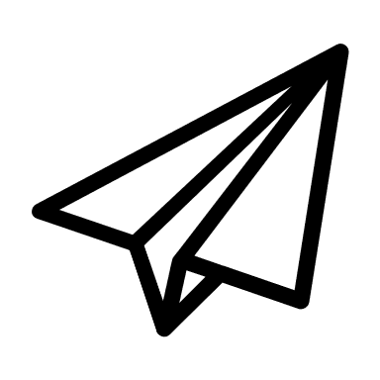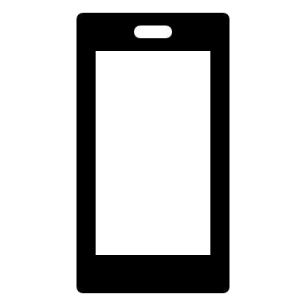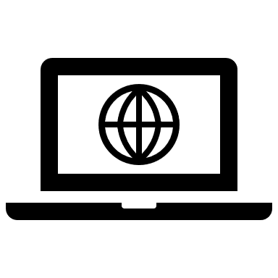

WIRELESS

NETWORK Internet of Things

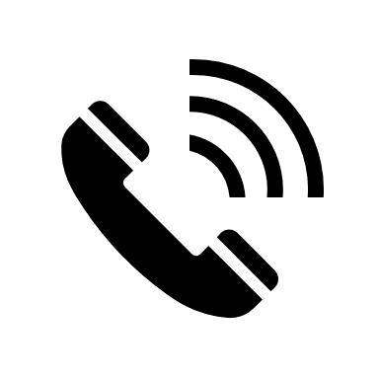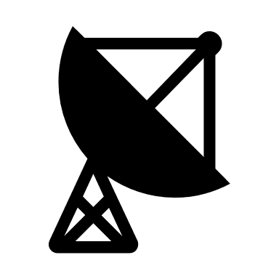

Cloud Computing